RATHISH P P  CH.SC.U4CSE24238 | Huffman Coding | EXP - 8

Question:
For the given phrase: Amrita Vishwa Vidyapeetham Chennai
find the Huffman coding.
Method of solving:
Total characters: 32
Frequency table:
Character | Count (Frequency)
a | 6
i | 3
h | 3
e | 3
m | 2
t | 2
[space] | 2
v | 2
n | 2
r | 1
s | 1
w | 1
d | 1
y | 1
p | 1
c | 1

Build an Huffman tree:
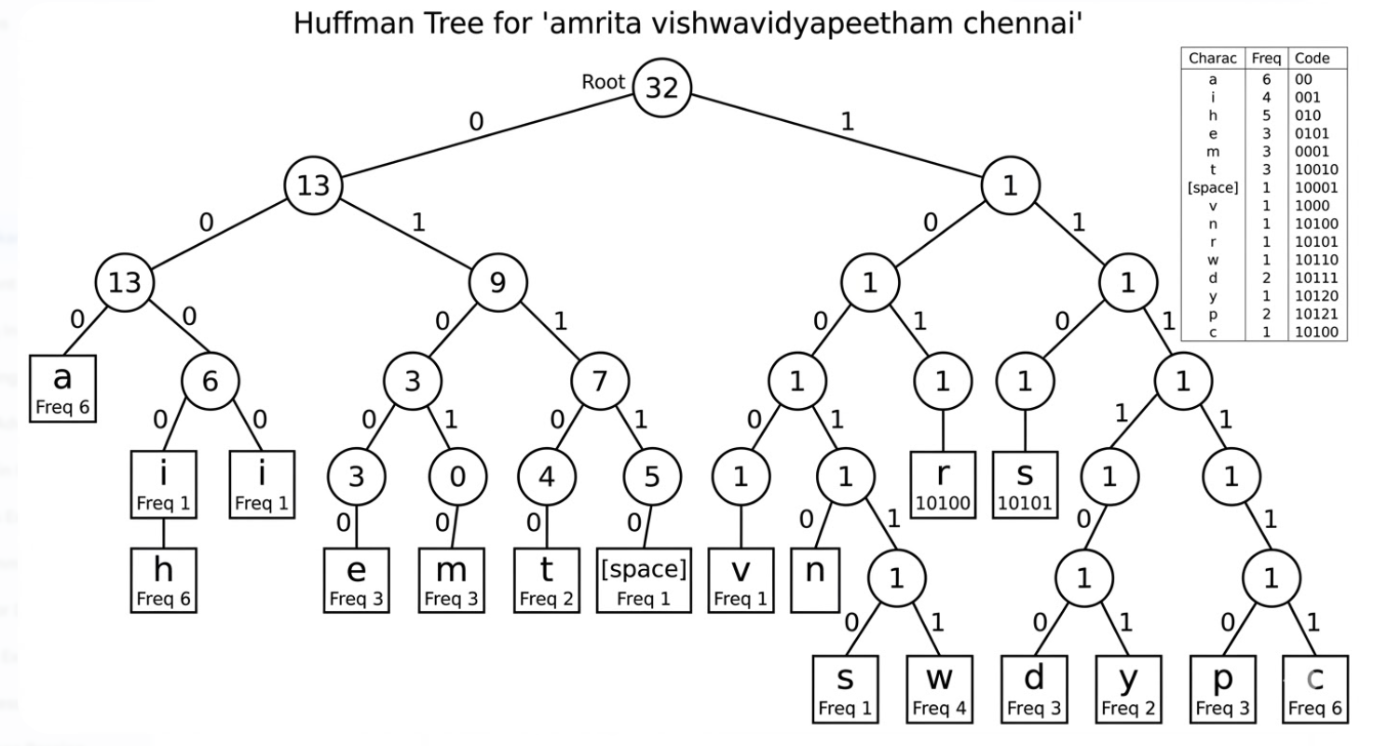

Final Huffman bitstring:
0011011101001110011000011110001110101011111110110001000111010111110000011001010010011011110011011011111010111101010011001001110

Code:
#include <stdio.h>
#include <stdlib.h>
#include <string.h>

// A Huffman tree node
struct MinHeapNode {
char data;
unsigned freq;
struct MinHeapNode *left, *right;
};

// A Min Heap: Collection of min-heap (or Huffman tree) nodes
struct MinHeap {
unsigned size;
unsigned capacity;
struct MinHeapNode** array;
};

// Utility function to allocate a new min heap node
struct MinHeapNode* newNode(char data, unsigned freq) {
struct MinHeapNode* temp = (struct MinHeapNode*)malloc(sizeof(struct MinHeapNode));
temp->left = temp->right = NULL;
temp->data = data;
temp->freq = freq;
return temp;
}

// Utility function to create a min heap of given capacity
struct MinHeap* createMinHeap(unsigned capacity) {
struct MinHeap* minHeap = (struct MinHeap*)malloc(sizeof(struct MinHeap));
minHeap->size = 0;
minHeap->capacity = capacity;
minHeap->array = (struct MinHeapNode**)malloc(minHeap->capacity * sizeof(struct MinHeapNode*));
return minHeap;
}

// Utility function to swap two min heap nodes
void swapMinHeapNode(struct MinHeapNode** a, struct MinHeapNode** b) {
struct MinHeapNode* t = *a;
*a = *b;
*b = t;
}

// The standard minHeapify function
void minHeapify(struct MinHeap* minHeap, int idx) {
int smallest = idx;
int left = 2 * idx + 1;
int right = 2 * idx + 2;

if (left < minHeap->size && minHeap->array[left]->freq < minHeap->array[smallest]->freq)
smallest = left;

if (right < minHeap->size && minHeap->array[right]->freq < minHeap->array[smallest]->freq)
smallest = right;

if (smallest != idx) {
swapMinHeapNode(&minHeap->array[smallest], &minHeap->array[idx]);
minHeapify(minHeap, smallest);
}
}

// Utility function to check if size of heap is 1
int isSizeOne(struct MinHeap* minHeap) {
return (minHeap->size == 1);
}

// Standard function to extract minimum value node from heap
struct MinHeapNode* extractMin(struct MinHeap* minHeap) {
struct MinHeapNode* temp = minHeap->array[0];
minHeap->array[0] = minHeap->array[minHeap->size - 1];
--minHeap->size;
minHeapify(minHeap, 0);
return temp;
}

// Utility function to insert a new node to Min Heap
void insertMinHeap(struct MinHeap* minHeap, struct MinHeapNode* minHeapNode) {
++minHeap->size;
int i = minHeap->size - 1;
while (i && minHeapNode->freq < minHeap->array[(i - 1) / 2]->freq) {
minHeap->array[i] = minHeap->array[(i - 1) / 2];
i = (i - 1) / 2;
}
minHeap->array[i] = minHeapNode;
}

// Standard function to build min heap
void buildMinHeap(struct MinHeap* minHeap) {
int n = minHeap->size - 1;
for (int i = (n - 1) / 2; i >= 0; --i)
minHeapify(minHeap, i);
}

// Utility function to check if this node is leaf
int isLeaf(struct MinHeapNode* root) {
return !(root->left) && !(root->right);
}

// Creates a min heap of capacity equal to size and inserts all characters
struct MinHeap* createAndBuildMinHeap(char data[], int freq[], int size) {
struct MinHeap* minHeap = createMinHeap(size);
for (int i = 0; i < size; ++i)
minHeap->array[i] = newNode(data[i], freq[i]);
minHeap->size = size;
buildMinHeap(minHeap);
return minHeap;
}

// The main function that builds Huffman tree
struct MinHeapNode* buildHuffmanTree(char data[], int freq[], int size) {
struct MinHeapNode *left, *right, *top;
struct MinHeap* minHeap = createAndBuildMinHeap(data, freq, size);

// Iterate while size of heap doesn't become 1
while (!isSizeOne(minHeap)) {
left = extractMin(minHeap);
right = extractMin(minHeap);

// '$' is a special value for internal nodes, not used
top = newNode('$', left->freq + right->freq);
top->left = left;
top->right = right;
insertMinHeap(minHeap, top);
}
return extractMin(minHeap);
}

// Prints an array of size n
void printCodes(struct MinHeapNode* root, int arr[], int top) {
if (root->left) {
arr[top] = 0;
printCodes(root->left, arr, top + 1);
}
if (root->right) {
arr[top] = 1;
printCodes(root->right, arr, top + 1);
}
if (isLeaf(root)) {
printf("'%c' (Freq: %d) | Code: ", root->data, root->freq);
for (int i = 0; i < top; ++i)
printf("%d", arr[i]);
printf("\n");
}
}

// Main function to build and print Huffman Codes
void HuffmanCodes(char data[], int freq[], int size) {
struct MinHeapNode* root = buildHuffmanTree(data, freq, size);
int arr[100], top = 0;
printf("Huffman Codes for the given characters:\n");
printf("---------------------------------------\n");
printCodes(root, arr, top);
}

int main() {
char text[] = "amrita vishwavidyapeetham chennai";
int freq[256] = {0};

// Step 1: Calculate frequencies of each character
for (int i = 0; text[i] != '\0'; i++) {
freq[(unsigned char)text[i]]++;
}

// Step 2: Extract unique characters and their non-zero frequencies
char uniqueChars[256];
int charFreqs[256];
int size = 0;

for (int i = 0; i < 256; i++) {
if (freq[i] > 0) {
uniqueChars[size] = (char)i;
charFreqs[size] = freq[i];
size++;
}
}

// Step 3: Generate the Huffman Tree and print the codes
printf("Original Phrase: \"%s\"\n\n", text);
HuffmanCodes(uniqueChars, charFreqs, size);

return 0;
}

Output:
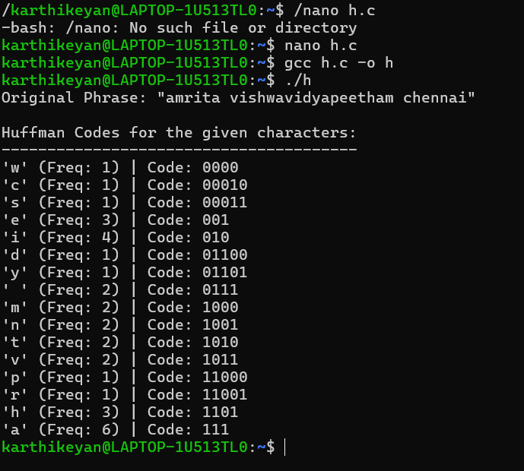
Interpretation:
It scans your phrase and tallies exactly how often each character appears. It places all the characters into a priority queue that constantly keeps the least frequent characters at the very top. The program repeatedly pulls the two rarest nodes, merges them into a single parent node (combining their frequencies), and puts that parent back in the queue. It repeats this until everything is connected into one giant tree. To generate the codes, it traces the path from the top of the tree down to each letter. Going down a left branch adds a 0, and a right branch adds a 1. Because of how the tree is built, frequent letters (like 'a') stay near the top and get short codes, while rare letters (like 'w') are pushed to the bottom and get long codes.

